Creating a Client Application

## Setting up the project

1. Set up a new visual studio project.
2. Add as a reference StromoLight_Objects.dll this will provide all the needed files (stromohab_08\Visual Studio Solutions\StromoLight_Objects\StromoLight_Objects\bin\Release\Stromolight_Objects.dll)

## Connecting and registering for the events

The following code connects to the server and then starts the cameras.

It then registers for the events, in this case for joints and trackables.

####Member Variabels####

private List<Stromohab_MCE.Trackable> trackableList = new List<Stromohab_MCE.Trackable>();

private List<Stromohab_MCE.Joint> jointList = new List<Stromohab_MCE.Joint>();

####END Member Variables####

####Connect#####

System.Net.IPEndPoint tempIpAddress = new System.Net.IPEndPoint(System.Net.IPAddress.Parse("144.32.137.126"), 8001);

Stromohab_MCE_Connection.TCPProcessor.ConnectToServer(tempIpAddress);

Stromohab_MCE_Connection.SendMCECommand.StartCameras();

Stromohab_MCE_Connection.TCPProcessor.JointListReceivedEvent += new Stromohab_MCE_Connection.TCPProcessor.JointListReceivedHandler(TCPProcessor_JointListReceivedEvent);

Stromohab_MCE_Connection.TCPProcessor.TrackableListReceivedEvent += new Stromohab_MCE_Connection.TCPProcessor.TrackableListReceivedHandler(TCPProcessor_TrackableListReceivedEvent);

####END Connect####

And here are the event handlers, note that a new copy must be made, not a refence otherwise if the event fires while a foreach loop is running through the loop the program will stop working

####Event Handlers####

void TCPProcessor_TrackableListReceivedEvent(List<Stromohab_MCE.Trackable> newTrackableList)

{

trackableList = new List<Stromohab_MCE.Trackable>(newTrackableList);

}

void TCPProcessor_JointListReceivedEvent(List<Stromohab_MCE.Joint> newJointList)

{

jointList = new List<Stromohab_MCE.Joint>(newJointList);

}

####END Event Handlers####

After this the variables trackableList and jointList will be constantly updated with the newest data from the camera.

Aswell as joints and trackables there are the other events that were present in the previous server and an event for FilteredMarkerLists however this is not yet working, if it is fixed use it in the same way a the MarkerList, but use FilteredMarkerList.listOfMarkers to get the list of markers.

## Working with List<Stromohab_MCE.Trackable> & List<Stromoab_MCE.Joint>

The easiest way to operate on the list is to use a foreach loop.

Additionally by using a Switch statement inside that loop specific operations can be performed depending on the Trackable.

foreach (Stromohab_MCE.Trackable trackable in trackableList)

{

#CODE#

Switch(trackable.ID)

{

Case “1”:

Left Foot Command

Break;

}

}

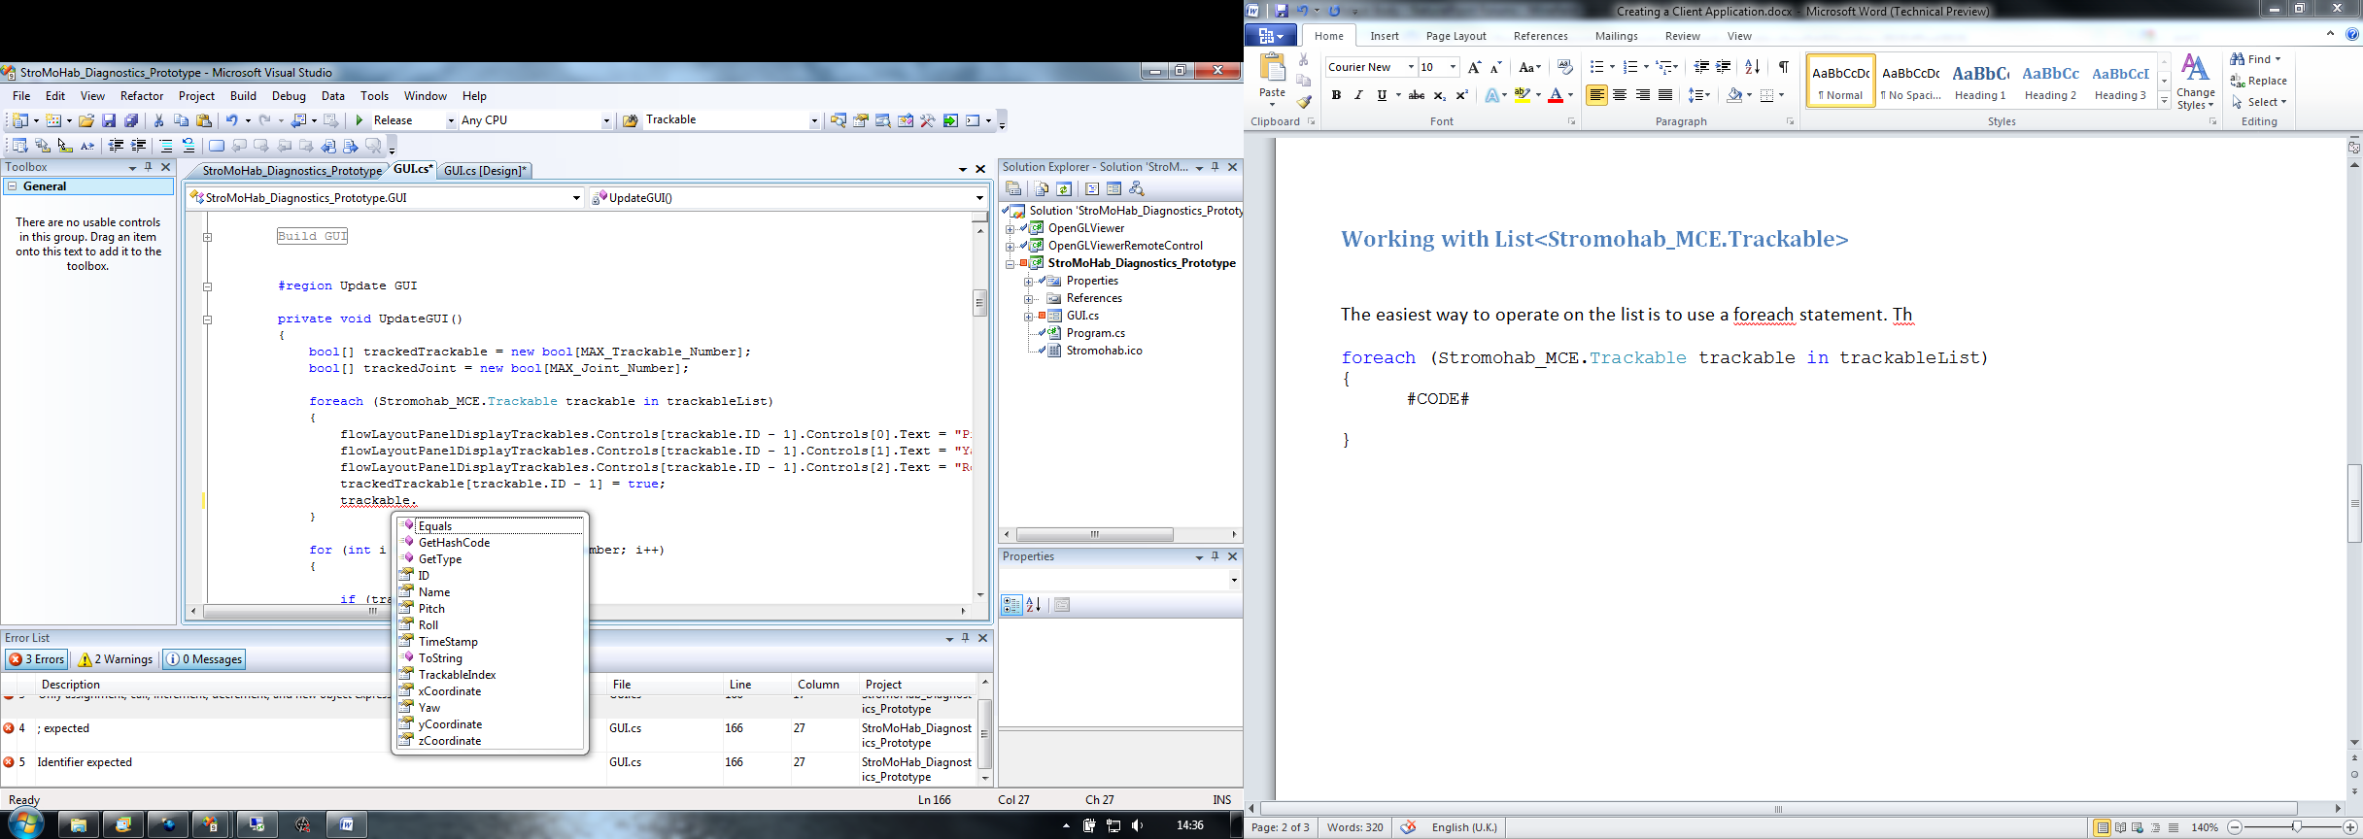Here is a screen shot of the options avaliable inside the foreach loop when applied to trackable.

All of the details needed are avaliable as properties and are fully explained in the Trackable.cs file (Code\Classes\Common\Trackable.cs) as xml comments so clicking on a property will bring up a tool tip showing its description

The same goes for joints which are managed in exactly the same way. The source code for joints is Joint.cs (Code\Classes\Common\Joint.cs).

Both Trackables and Joints have an ID number, this is unique and is defined either in the Trackable.tra file created using the Tracking Tools Software or in the joints.xml file. A list of the ID numbers can be found in “Trackable and Joint ID Numbers.doc” and should be added to as more are defined.